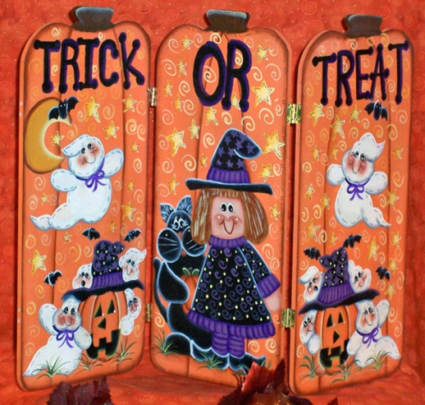

TRICK - OR -TREATING HOURS FOR THE VILLAGE OF BRISTOL:

OCTOBER 31ST FROM 3 - 6 P.M.

The Village would like to remind all residents to be safe during trick-or-treating times. Please follow the recommendations designed to curb the spread of COVID-19 by social distancing and wearing a mask.