City of Kenosha Complete Count Committee to hold 2020 Census events Aug. 24-28
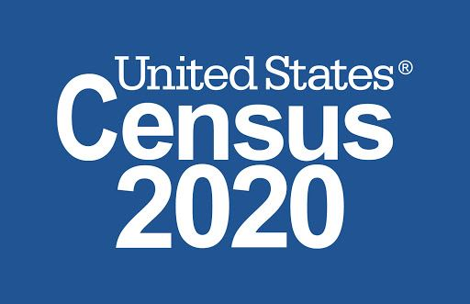
The City of Kenosha Complete Count Committee has organized a series of events during Kenosha Be Counted Week, Aug. 23-29, to help residents complete their 2020 Census forms.
Internet access and assistance from census staff will be available at different locations throughout the week.
Events will be held at the following locations and times:
- Brass Community School, 6400 15th Ave., 9:30 to 11:30 a.m. Monday, Aug. 24.
- Boys & Girls Club of Kenosha, 1300 52nd St., noon to 2 p.m. Monday, Aug. 24.
- Uptown Library, 2419 63rd St., 10 a.m. to noon Tuesday, Aug. 25. (Note: Bilingual services available at this location.)
- Supermercado Corrales, 3933 52nd St., 4 to 6 p.m. Tuesday, Aug. 25. (Note: Bilingual services available at this location.)
- Jefferson Elementary School, 1832 43rd St., 9:30 to 11:30 a.m. Wednesday, Aug. 26. (Note: Bilingual services available at this location.)
- St. Mark Catholic Church, 7117 14th Ave., 4 to 6 p.m. Wednesday, Aug. 26. (Note: Bilingual services available at this location.)
- Lincoln Middle School, 6729 18th Ave., 2:30 to 4:30 p.m. Thursday, Aug. 27.
- Edward Bain School of Language and Art, 2600 50th St., 9:30 to 11:30 a.m. Friday, Aug. 28.
- Grace Lutheran Church, 2006 60th St., 2 to 4 p.m. Friday, Aug. 28.
The Kenosha Public Library Outreach Van will be at each of these sites, offering Wi-Fi access. The event flyer may be viewed here.
Those who would like to complete the census on their own may still do so at www.2020census.gov.
The results of the 2020 Census will inform funding and planning for health services, school lunch programs, emergency services, transportation, and more. So make sure everyone in your household is counted!

