Resurfacing to begin on portion of Highway MB in Bristol
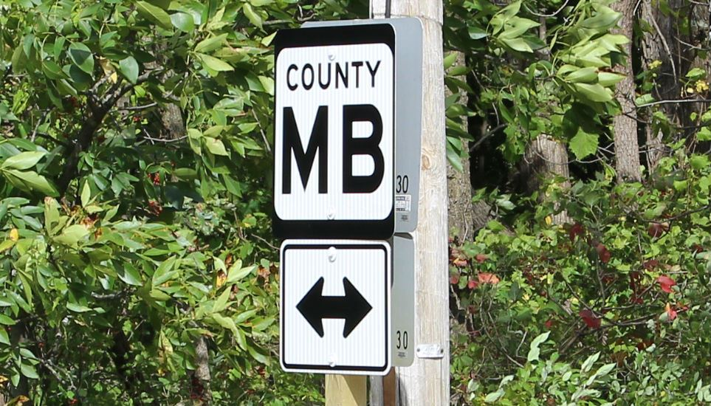
The Kenosha County Division of Highways is set to begin work Tuesday, Sept. 10, on a resurfacing of Highway MB (152nd Avenue) between Highway Q (104th Street) and Highway WG (128th Street) in the Village of Bristol.
The road will remain open to traffic during the project, with flagging operations in place. Drivers are urged to expect delays.
Project completion is expected by Friday, Sept. 20. The work will be conducted weather permitting and is subject to change.

